

**Product Dissection for Amazon**

### **Company Overview:**

Amazon, founded in 1994 by Jeff Bezos, is one of the world's largest e-commerce platforms. Initially started as an online bookstore, Amazon has evolved into a global marketplace offering an extensive range of products, including electronics, apparel, household goods, and more. The company's mission is to be Earth's most customer-centric company, where customers can find and discover anything they might want to buy online at the lowest possible prices.

Amazon's innovative approach includes pioneering services such as Amazon Prime, which offers fast shipping, exclusive deals, and streaming services. The company's investment in technology, including its cloud computing service AWS (Amazon Web Services), has positioned it as a leader not only in retail but also in IT infrastructure. Additionally, Amazon has ventured into artificial intelligence with products like Alexa, its voice-activated virtual assistant, further broadening its impact on everyday life.

### **Product Dissection and Real-World Problems Solved by Amazon:**

Amazon has tackled numerous real-world challenges with its innovative product offerings and services, creating a seamless shopping experience for millions of users worldwide. By establishing a comprehensive marketplace and leveraging advanced technology, Amazon effectively addresses issues such as limited product availability, inefficient delivery systems, and the need for customer reviews to make informed purchasing decisions.

### **Case Study: Real-World Problems and Amazon's Innovative Solution**

Amazon, a global e-commerce giant, has profoundly transformed online shopping by addressing several real-world challenges with its innovative solutions. Through strategic use of technology and a customer-centric approach, Amazon has redefined the retail experience, making it more convenient, efficient, and reliable.

#### 

**Problem 1: Limited Product Availability**

**Challenge:** Traditional retail stores have limited physical space, restricting the variety and quantity of products they can stock. This limitation often leads to customers being unable to find specific items or having to visit multiple stores to complete their shopping.

**Amazon's Solutions:**

* **Vast Online Marketplace:** Amazon's platform hosts millions of products across various categories, from books and electronics to groceries and fashion. This extensive selection ensures that customers can find almost any item they are looking for.
* **Third-Party Sellers:** By allowing third-party sellers to list their products on Amazon, the company significantly expands its inventory without the need for additional physical storage. Sellers benefit from Amazon's massive customer base, while customers gain access to a wider range of products.
* **Global Reach:** Amazon operates multiple international marketplaces, enabling customers to access products from around the world. This global reach helps in providing items that may not be available locally.

**Problem 2: Inefficient Delivery Systems**

**Challenge:** Traditional retail often requires customers to visit stores, which can be time-consuming and inconvenient. Additionally, shipping from online stores can be slow and unreliable, leading to customer dissatisfaction.

**Amazon's Solutions:**

* **Amazon Prime:** This subscription service offers members benefits like free two-day shipping, same-day delivery, and access to exclusive deals. Prime's fast shipping options cater to the growing demand for quick and reliable delivery.
* **Advanced Logistics Network:** Amazon has invested heavily in its logistics and fulfilment infrastructure. With numerous fulfilment centres strategically located around the globe, Amazon can process and ship orders quickly and efficiently.
* **Innovative Delivery Methods:** Amazon continues to explore and implement new delivery methods, such as drone delivery through Amazon Prime Air and the Amazon Flex program, which leverages independent contractors for last-mile delivery. These innovations aim to further reduce delivery times and enhance customer convenience.

**Problem 3: Lack of Customer Reviews for Informed Purchasing Decisions**

**Challenge:** In physical stores, customers often lack access to detailed product information and reviews, making it difficult to make informed purchasing decisions. Online shopping without reviews can also lead to uncertainty and distrust.

**Amazon's Solution:**

* **Comprehensive Review System:** Amazon's platform allows customers to leave detailed reviews and ratings for products they have purchased. These reviews provide valuable insights into product quality, performance, and user experience, helping other customers make informed decisions.
* **Verified Purchase Reviews:** Amazon marks reviews from verified purchases, ensuring that the feedback is genuine and trustworthy. This system helps maintain the credibility of reviews and fosters trust among customers.
* **Q&A Section:** In addition to reviews, Amazon features a question-and-answer section on product pages where potential buyers can ask questions and receive answers from other customers or the sellers themselves. This feature provides additional context and information about the products.

**Problem 4: High Prices and Limited Discounts**

**Challenge:** Customers often face high prices and limited discount options in traditional retail stores, making shopping more expensive.

**Amazon's Solutions:**

* **Competitive Pricing:** Amazon employs dynamic pricing strategies, regularly adjusting prices to remain competitive. The platform often offers lower prices than traditional retail stores, providing better value for customers.
* **Deals and Discounts:** Amazon frequently runs promotions, discounts, and special deals, including the annual Prime Day event, where Prime members can access exclusive deals across a wide range of products. These offers help customers save money and make the shopping experience more attractive.
* **Amazon Warehouse and Outlet:** Amazon Warehouse offers discounts on returned, refurbished, and open-box items, while Amazon Outlet provides deals on overstocked items. These sections allow customers to find quality products at reduced prices.

**Problem 5: Limited Access to International Products**

**Challenge:** Customers looking for unique or specific products from other countries often face difficulties in finding and purchasing them locally.

**Amazon's Solutions:**

* **Global Shipping Options:** Amazon offers international shipping on a wide range of products, allowing customers to purchase items from different countries. This service expands access to unique products that may not be available in the customer's home country.
* **Localised Marketplaces:** Amazon operates localised versions of its marketplace in multiple countries, catering to the specific needs and preferences of regional customers. These localised platforms provide a tailored shopping experience with relevant products and services.

#### **Conclusion:**

Founded by Jeff Bezos in 1994, Amazon has transformed from an online bookstore into a global e-commerce powerhouse. It strives to be Earth's most customer-centric company by offering a vast array of products at competitive prices. Innovations like Amazon Prime and AWS ensure fast, reliable service and leadership in technology and retail. Amazon addresses challenges with extensive product availability and efficient delivery, overcoming traditional retail limitations. Customer reviews and dynamic pricing enhance the shopping experience, while global shipping options cater to diverse needs. Amazon's evolution reflects its dedication to innovation and customer satisfaction in the digital age.

### 

**Top Features of Amazon include:**

1. **User Accounts:** Customers can create accounts to manage orders, maintain wishlists, and store personal information securely.
2. **Product Listings:** Detailed pages for each product feature descriptions, images, pricing, and real-time availability updates.
3. **Customer Reviews:** Users can contribute feedback and ratings based on their experiences with purchased products, helping others make informed decisions.
4. **Shopping Cart and Checkout:** Seamless processes allow users to add items to their cart, review them, apply discounts or promotional codes, and proceed through a secure checkout system.
5. **Order Tracking:** Customers can monitor the status of their orders, receiving updates on shipping and delivery times for enhanced convenience.
6. **Prime Membership:** Subscribers enjoy benefits such as expedited shipping, exclusive deals, streaming services, and more, enhancing the overall shopping experience.
7. **AWS (Amazon Web Services):** Cloud computing services provide businesses with scalable and reliable infrastructure, powering many online services and applications globally.

### **Schema Description:**

Amazon's schema encompasses diverse entities that delineate various facets of the platform. Key entities include Users, Products, Orders, Reviews, Sellers, and more. Each entity is defined by specific attributes detailing its properties and interactions with other entities, forming a comprehensive framework that underpins Amazon's operational structure. These entities not only facilitate seamless user interactions but also enable robust functionalities such as personalised recommendations, efficient order processing, and dynamic marketplace dynamics.

**Suppliers:**

Entities representing external providers of goods or services, with unique identifiers and supplementary details.

* **Supplier_id(Primary Key):** Unique identifier for the supplier.
* **Supplier_name:** Name of the supplier.
* **other_supplier_details:** Additional information about the supplier (e.g., Amazon or Starbucks).

**Customers:**

contact information, and additional details for personalised service.

* **Customer_id(Primary Key):** Unique identifier for the customer.
* **Customer_name:** Name of the customer.
* **Customer_phone:** Phone number of the customer.
* **Customer_email:** Email address of the customer.
* **other_customer_details:** Additional information about the customer.

**Addresses:**

Locations associated with customers or orders, identified by unique IDs and detailed attributes for accurate delivery.

* **address_id(Primary Key):** Unique identifier for the address.
* **line_1_number_building:** Building number or name.
* **line_2_number_street:** Street number or name.
* **line_3_area_locality:** Area or locality.
* **City:** City of the address.
* **Zip_postcode:** ZIP code or postal code.
* **State_province_county:** State, province, or county.
* **iso_Country_code:** ISO country code.
* **other_address_details:** Additional information about the address.

**Products:**

Items available for purchase, categorised by type codes, priced with supplier associations, and detailed specifications.

* **Product_id(Primary Key):** Unique identifier for the product.
* **Product_type_code**: Code representing the type of product.
* **supplier_id:** Identifier for the supplier of the product.
* **Product_price:** Price of the product.
* **Other_product_details:** Additional information about the product.

**Customer_Orders:**

Records of customer transactions, including order status, payment details, and associated product information.

* **order_id(Primary Key):** Unique identifier for the order.
* **Customer_id:** Identifier for the customer placing the order.
* **Customer_payment_method_id:** Payment method identifier for the customer.
* **order_status_code:** Code representing the status of the order.
* **date_order_placed:** Date when the order was placed.
* **date_order_paid:** Date when the order was paid.
* **order_order_price:** Total price of the order.
* **Other_order_details:** Additional information about the order (e.g., books, CDs, or coffee).

**Customer_Orders_Products:**

Specific items within customer orders, identified by product IDs with quantities and optional comments.

* **order_id(Primary Key):** Identifier for the order.
* **Product_id:** Identifier for the product.
* **quantity:** Quantity of the product ordered.
* **comments:** Additional comments about the product in the order.

**Customer_Orders_Delivery:**

Delivery details for customer orders, including status codes and reported dates for tracking purposes.

* **order_id(Primary Key)**: Identifier for the order.
* **date_reported:** Date when the delivery was reported.
* **delivery_status_code:** Code representing the delivery status.

**Customer_Addresses:**

Specific locations linked to customers or orders, characterised by unique IDs and comprehensive location details.

* **address_id(Primary Key):** Unique identifier for the address.
* **line_1_number_building:** Building number or name.
* **line_2_number_street:** Street number or name.
* **line_3_area_locality:** Area or locality.
* **City:** City of the address.
* **Zip_postcode:** ZIP code or postal code.
* **State_province_county:** State, province, or county.
* **iso_Country_code:** ISO country code.
* **other_address_details:** Additional information about the address.

**Ref_Address_Types:**

Reference data for types of addresses, categorised by codes with descriptions and additional specifications.

* **Address_type_code(Primary Key):** Code representing the type of address.
* **address_type_description:** Description of the address type (e.g., Billing, residence).
* **other_address_type_details:** Additional information about the address type.

**Relationships are:**

**Suppliers and Products**

* A Supplier supplies multiple Products.
* Each Product is supplied by one Supplier.

**Customers and Customer_Orders**

* A Customer places multiple Orders.
* Each Order is placed by one Customer.

**Addresses and Customer_Addresses**

* An Address can be associated with multiple Customer Addresses.
* Each Customer Address has one Address.

**Customer_Orders and Customer_Orders_Products**

* An Order can contain multiple Products.
* Each Product in an order is part of one Order.

**Products and Customer_Orders_Products**

* A Product can be part of multiple Orders.
* Each Product in an order is one specific Product.

**Customer_Orders and Customer_Orders_Delivery**

* An Order can have multiple Delivery records.
* Each Delivery record is for one specific Order.

**Customer_Orders and Customers**

* An Order is associated with one Customer.
* A Customer can place multiple Orders.

**Customer_Addresses and Ref_Address_Types**

* A Customer Address can have one Address Type.
* An Address Type can be associated with multiple Customer Addresses.

**ER Diagram:**

Let's design an ER diagram to illustrate the relationships and attributes within the schema. This diagram will provide a clear visual representation, highlighting the key entities and their interactions. By studying this diagram, you'll understand the complex interplay between various components, offering insight into the structure and functionality of the data model.

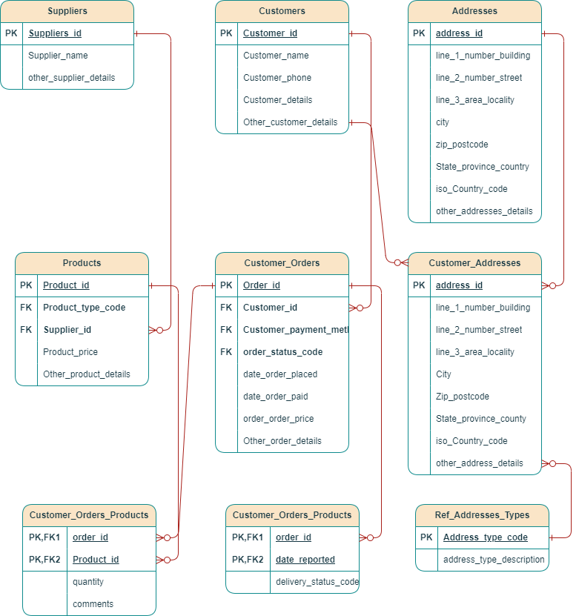

### 

### **Conclusion**

Amazon, established by Jeff Bezos in 1994, has grown from an online bookstore into a global e-commerce giant. Its mission is to be Earth's most customer-centric company, offering a wide range of products at competitive prices. Innovations like Amazon Prime and AWS ensure fast, reliable services and leadership in both retail and technology sectors. Amazon addresses real-world challenges such as limited product availability and inefficient delivery systems by leveraging a vast online marketplace and an advanced logistics network. Customer reviews and competitive pricing enhance the shopping experience, while global shipping options cater to diverse customer needs. Amazon's evolution showcases its commitment to innovation and customer satisfaction.

Video Link - [Product_Dissection_for_Amazon.mp4](https://drive.google.com/file/d/1Y_21VYuMS_neONzMvc2sxdDnsd6TeXTx/view?usp=sharing)